MARSHFIELD SUMMERFEST 2015: Welcome Back Summer!
Summer is right around the corner! Join the Marshfield Chamber of Commerce together with our community to ‘welcome back summer’ on June 28th in Marshfield Center. This event is focused on families with children with the “World’s Shortest Parade” kicking off at 11:00AM followed by children’s activities, amusements, music & more! Local vendors will line the streets with food, crafts and local favorites.

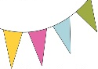
$1,000 – Annual Corporate Marshfield Chamber Sponsor
This level of sponsorship includes: a large corporate banner and recognition at all of our events for your business, and free booth space at each event.

$500 – Sand Castle Sponsor
This level of sponsorship includes a corporate banner and recognition at Summerfest, website listing on Summerfest event page, 10 X 10 booth space.

$250 – Surfboard Sponsor
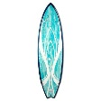
Sponsor a children’s amusement at Summerfest! You will receive a sign on the specific amusement on site at Summerfest and a free 10 X 10 booth space.

$100 – Sunshine Sponsor
Sponsor a children’s activity at Summerfest! You will receive a sign on or around the specific activity you have sponsored at the event.

$50 – Starfish Sponsor
Help fund Summerfest by making a $50 donation towards the event. Your name will be recognized on a sign board at the Volunteer tent for your patronage!

Thank you for your continued support!
Please complete the back of this form
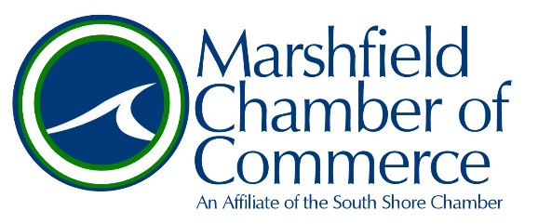
Thank you for your consideration in sponsoring MARSHFIELD SUMMERFEST 2015!

SAVE A STAMP! Visit us online to complete the sponsorship application at:
www.marshfieldchamber.org

OR

Complete the information below and mail this form and payment to:
Marshfield Chamber of Commerce, PO Box 238, Marshfield MA 02050

Business Name _________________________________________________________

Contact _________________________________________________________

Level of Sponsorship: $1000 $500 $250 $100 $50

Credit Card Type: Visa Mastercard AMEX Discover

# __________________________________________________________________________

Expiration _________/ ___________ 3 Digit Security Code ______________________

Billing Address _______________________________________________________________

___________________________________________________________________________

Please send a high resolution logo to astanford@marshfieldchamber.org for your sponsorship signage provided by the Marshfield Chamber.

Contact us with any addition questions or concerns!

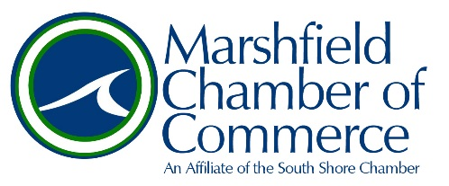
781-834-MCOC · www.marshfieldchamber.org · @marshfldchamber

